
Visualization Tool for Electric Vehicle Charge and Range Analysis
This document outlines a data-driven approach to analyze Electric Vehicle (EV) charging behavior, battery range, and adoption trends using interactive Tableau dashboards. It details the project objectives, methodology, and key insights derived from a comprehensive analysis of global and Indian EV datasets.

Project By:
Kabir shaikh

Varun yadav

Ritesh waingde

Ritesh Nejkar

TEAM ID: LTVIP2025TMID47397

Date: 28 June 2024


Project Overview

The project titled "Visualization Tool for Electric Vehicle Charge and Range Analysis" focuses on
analyzing key data related to electric vehicles (EVs) using Tableau.
It aims to deliver clear and interactive dashboards that visualize EV performance, battery range, charging types, efficiency, and adoption trends in both global and Indian markets.

Purpose

The purpose of this project is to transform raw EV datasets into insightful visualizations that support data-driven decisions for consumers, policymakers, and researchers.
By leveraging Tableau, the project highlights trends in EV model efficiency, price-to-range ratios, and the availability of charging infrastructure across regions.

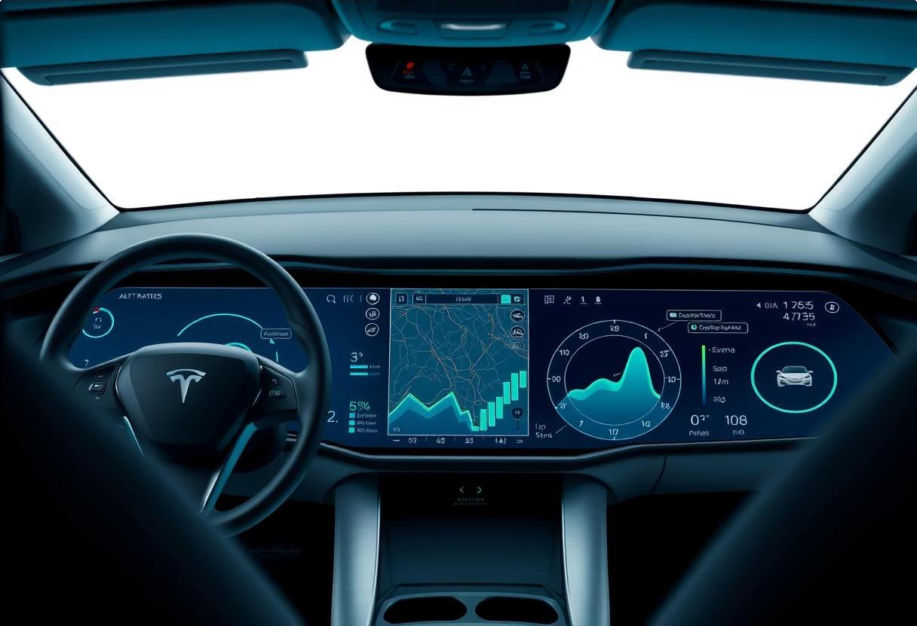

IDEATION PHASE

' Problem Statement

With the growing shift toward electric vehicles (EVs), understanding key aspects such as range, price, charging infrastructure, and adoption trends has become critical. The problem is that raw EV data from various sources is often fragmented and difficult to interpret without a visual tool. This project aims to solve that by transforming complex EV datasets into insightful dashboards.

PDF file

' Empathy Map Canvas

The empathy map was built with the end-user in mind 4 typically, EV buyers, researchers, or policy makers. We considered what users see (market data, models), hear (brand claims), think (cost vs range), and feel (confused or uncertain about EV decisions). This helped guide our design to make the dashboard easy to navigate, insightful, and reliable.

PDF file

' Brainstorming

Our team conducted multiple brainstorming sessions to finalize the scope of the project. We evaluated different datasets, shortlisted key business questions like <Which EV offers best range?=,
<Where are charging stations located?=, and <What are the most affordable models?=. These ideas shaped the layout and filters of our Tableau dashboards.

PDF file

REQUIREMENT ANALYSIS

Customer Journey Map
1
2
3
4

Our target users are EV consumers and researchers who want to compare electric vehicle models based on cost, range, and charging options.
The typical customer journey:

- Awareness – Learns about EVs, confused by technical terms
- Research – Looks for model comparisons and
charging data
- Decision – Wants a simple dashboard to help decide based on price/range
- Action – Uses our dashboard to make a data- driven choice

Data Flow Diagram
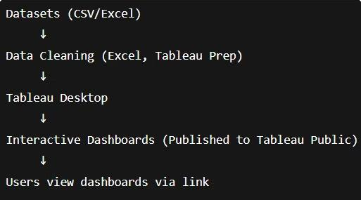

Solution Requirement
The solution must meet the following requirements:

Integrate and clean 4 different EV-related datasets
Present clear, interactive dashboards using Tableau
Allow filtering by model, price, country, charging type
Support both global and India-specific
analysis
Be easy to access and navigate for non-
technical user

Technology Stack

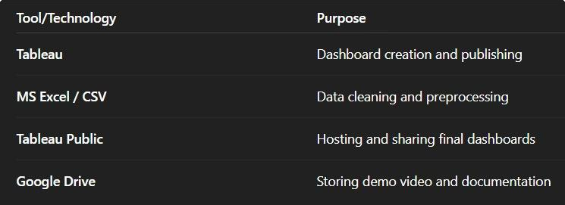

PROJECT DESIGN
In accordance with the SmartInternz project methodology, we systematically collected, explored, and refined several EV-related datasets. This rigorous process was crucial to ensure that only accurate and high-quality data would be used in the visualization phase, thereby guaranteeing the extraction of meaningful and reliable insights.

Problem-Solution Fit
The raw EV data available from multiple sources lacked structure, clarity, and visual insights.
Consumers and analysts needed a way to explore EV model performance, price- range comparisons, and infrastructure readiness.
Our solution bridges this gap by turning fragmented datasets into interactive Tableau dashboards, making the information accessible, visual, and actionable.

Proposed Solution
We developed two dashboards that visually explore:
Global and Indian EV model range, pricing, and efficiency
Regional charging infrastructure availability
Comparison of budget EV options for consumers
These dashboards allow users to filter by brand, model, charger type, or region 4 enabling tailored analysis and better decision-making.

Solution Architecture
Here9s a quick breakdown of our architecture:
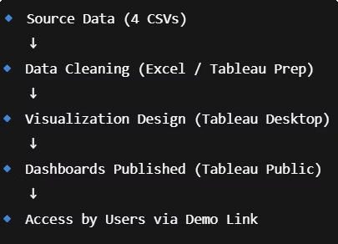

PROJECT PLANNING & SCHEDULING
Our project followed a meticulously structured approach, as guided by the SmartInternz program. This systematic process began with a thorough understanding of the raw data and culminated in the publication of interactive stories and dashboards. Below is a detailed, step-by-step breakdown of our methodology:

Week 1:
Team formation
Project topic selection
Dataset research and confirmation

Week 2:
Data cleaning and preprocessing
Initial dashboard planning and brainstorming

Week 3:
Dashboard creation in Tableau
Visual tuning and insights drafting.

Week 4:
Documentation and final demo preparation
Team review and submission

FUNCTIONAL AND PERFORMANCE TESTING

To ensure our dashboards were effective and user-friendly, we conducted basic functional and performance testing.
The goal was to confirm that all interactive elements worked correctly and that the dashboards performed smoothly when published online.

' Functional Testing
We verified that all dashboard features work as expected across
use cases:

' Filters respond correctly (Brand, Region, Body Style, Powertrain)
' All charts update dynamically based on filter input
' Tooltips display accurate values for each data point
' Dashboard navigates smoothly between global and India views

' Performance Testing

Performance was tested by checking:
1
2

Dashboard load time on different internet speeds (under 3 seconds on broadband)
Responsiveness across desktop
and mobile browsers
Data consistency – Verified no null values or mismatches post- cleaning
Publishing stability – Dashboards remained fully interactive after uploading to Tableau Public


PDF file

RESULTS

The project resulted in two fully functional and interactive dashboards built using Tableau.
These dashboards visualize key electric vehicle insights across global and Indian markets 4 helping users explore EV models, performance, pricing, and infrastructure with ease.

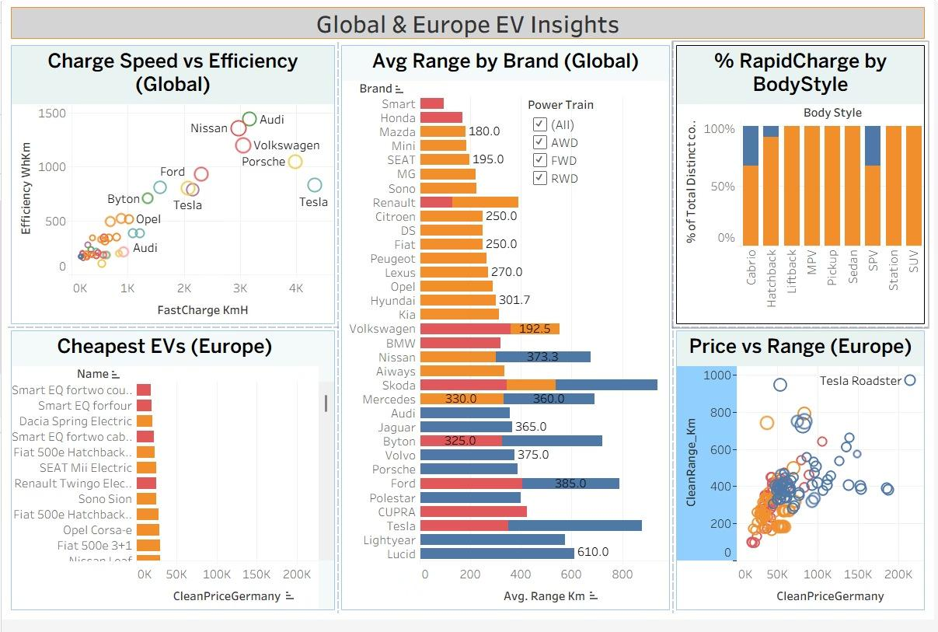
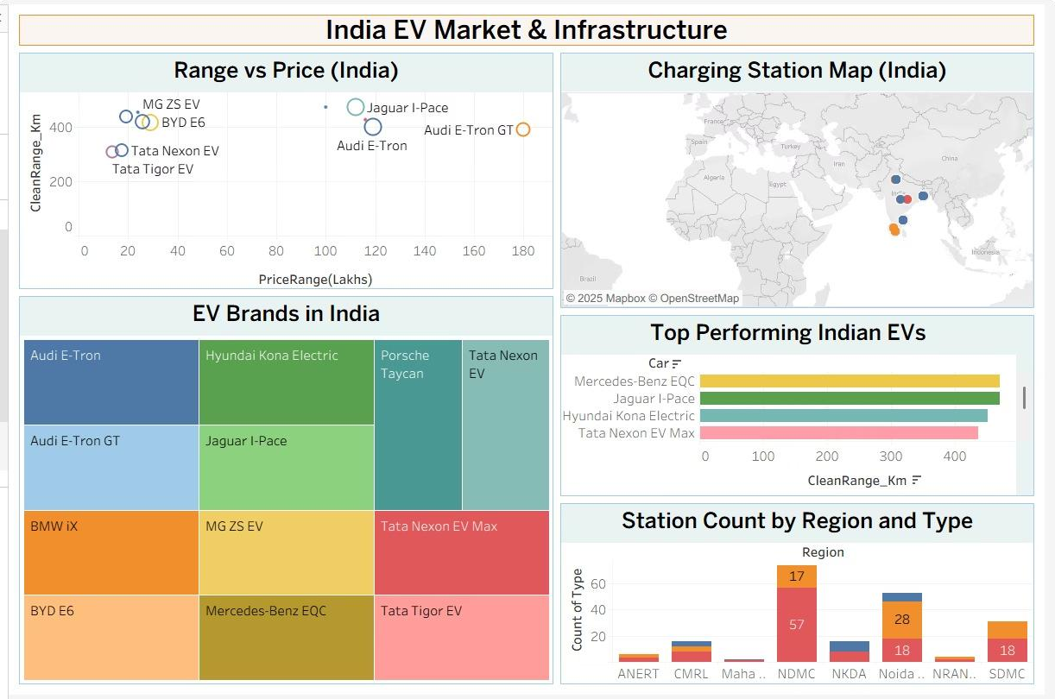

ADVANTAGES & DISADVANTAGES

Every project has strengths and limitations. This section outlines the key advantages of our dashboard-based EV analysis solution, as well as the challenges and limitations we encountered during development and testing.

ADVANTAGES
' Interactive Dashboards: Users can filter by region, brand, charger type, and EV models.
' Visual Clarity: Simplifies complex data for non-technical users.
' Global & Local Scope: Covers both global and Indian EV trends in a single project.
' No- Code Solution: Built entirely using Tableau without coding knowledge.

DISADVANTAGES
- Static Data: Dashboards rely on manually uploaded datasets and are not real-time.
- Device Responsiveness Limitations: Some Tableau visuals are harder to view on smaller screens.
- Dependent on Data Accuracy: Incomplete or outdated datasets can impact insights.
- Limited Predictive Capabilities: Focused on descriptive analysis, not forecasting.

Conclusion & Future Scope
The project offered a valuable opportunity to explore Electric Vehicle data through a practical lens. From raw datasets to interactive Tableau dashboards, we built a solution that highlights performance, charging behavior, and adoption trends, proving the feasibility of a robust EV data visualization tool.

 Successful Analysis
Successfully analyzed multiple EV datasets related to model performance, charging time, and battery range.

 Future Scope:

 Dashboard Development
Developed a comprehensive Tableau dashboard to support data-driven decision making.

 Functional Tool
Delivered a functional visualization tool that simplifies EV data interpretation for stakeholders.



Real-Time Data Integration
Connect live APIs or streaming EV data to update dashboards dynamically, providing the most current insights.
More KPIs & Filters
Introduce filters for cost, emission reduction, and user reviews to broaden insights and cater to diverse analytical needs.
Predictive Analytics
Apply forecasting techniques to predict EV market trends or battery lifespan, offering proactive strategic planning.
User Interface Improvements
Design cleaner, mobile-friendly dashboards for wider accessibility and an enhanced user experience across devices.


APPENDIX
This section provides all supporting information related to the project, including the datasets used, tools and platforms applied during development, and access links to the final dashboards and demo video.These references validate the analysis and ensure transparency of the solution built.

 Datasets Used:

- ElectricCarData_Clean.csv – Global EV specifications
- Cheapestelectriccars-EVDatabase.csv – Budget EV data (Europe)
- EVIndia.csv – Indian EV models and pricing
- electric_vehicle_charging_station_list.csv – Charging station locations in India.

 Tools & Platforms:

- Tableau Desktop & Tableau Public – Dashboard creation & publishing
- Microsoft Excel – Data cleaning and preprocessing
- Gamma – Project documentation & presentation
- Google Drive / YouTube – Hosting demo video

 Demo & Dashboard Access:





